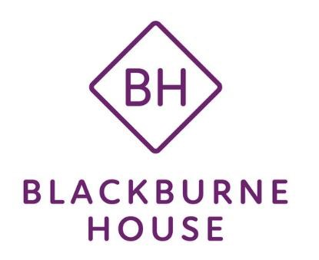

**Complaints Policy and**

**Procedure**

|  |  |
| --- | --- |
| **Version** | 4 |
| **Title of Policy** | Complaints Policy and Procedure |
| **Policy Owner** | ELT |
| **Date of Authorisation** | September 24 |
| **Authorised by** | Board |
| **Date for Review** | September 25 |

# Blackburne House Group General Complaints Procedure

The Blackburne House Group (BHG) is committed to the provision of high-quality service to all our customers. To continually improve our services, we need to know when we do not meet your expectations.

By listening and responding to the views of our customers, whatever those views might be, the Group ensures that we achieve the highest standards across the full range of services we offer.

# How to make a complaint

We aim to make this process as easy as we can. Therefore, wherever possible, we prefer that a complaint is dealt with immediately. However, if this is not possible, or if you do not feel that it is dealt with satisfactorily, you can of course make a formal complaint:

* in writing
* by e-mail
* by telephone
* in person, at a later date, if you make an appointment

What happens next?

1. Once we have received your complaint, we aim to reply within 15 working days from its receipt.

1. If we are unable to reply fully within that time, we will contact you to let you know what’s being done about your complaint and when you can expect a full reply.

1. The full reply will also include details of who you should contact if you are unhappy with how we have dealt with the complaint.

1. The procedure for the second response will be as above.

What else do we do?

* + All written complaints are logged.

* + A report is presented to the Education and Quality Committee who monitor the level and range of complaints made against the organisation.

* + The department against whom the complaint has been made is notified, if the complaint is not made directly to them.

* + The outcome of any written complaint is presented to the Senior Management Team.

* + If you are studying here, there is a separate complaints procedure detailed in the student handbook which deals with any complaints you may have regarding learning and curriculum.

* + If you have fully exhausted the complaints procedure, have evidence of this and remain dissatisfied, you can contact Liverpool City Region Combined Authority.

* + We realise that mistakes are made; however, it is our policy not to allow our staff to be the recipients of malicious complaints. If, after investigation, we find that a complaint is malicious we will take appropriate action which may result in restrictions on access to our services.

**The Blackburne House Group**

**Blackburne House**

**Blackburne Place**

**Liverpool L8 7PE t: 0151 709 4356 f: 0151 709 8293**

**e: reception@blackburnehouse.co.uk w:** [**www.blackburnehouse.co.uk**](http://www.blackburnehouse.co.uk/)